**What is DynamoDB**?

Amazon DynamoDB is a fully managed NoSQL database service provided by Amazon Web Services (AWS). It is designed to deliver fast and predictable performance at any scale. DynamoDB offers a flexible schema-less data model, allowing you to store and retrieve data using simple key-value or document-based operations.

**Step 1:** Creating a DynamoDB Table.

* Click Create Table

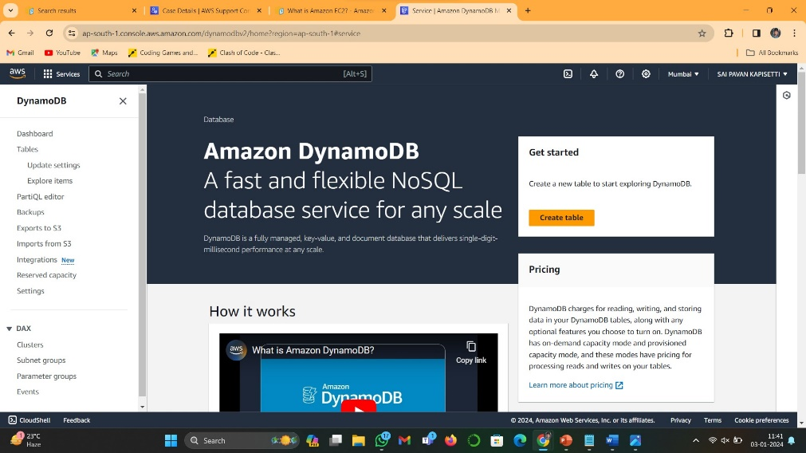

* In Table detail, input table name, partition key, and sort key.

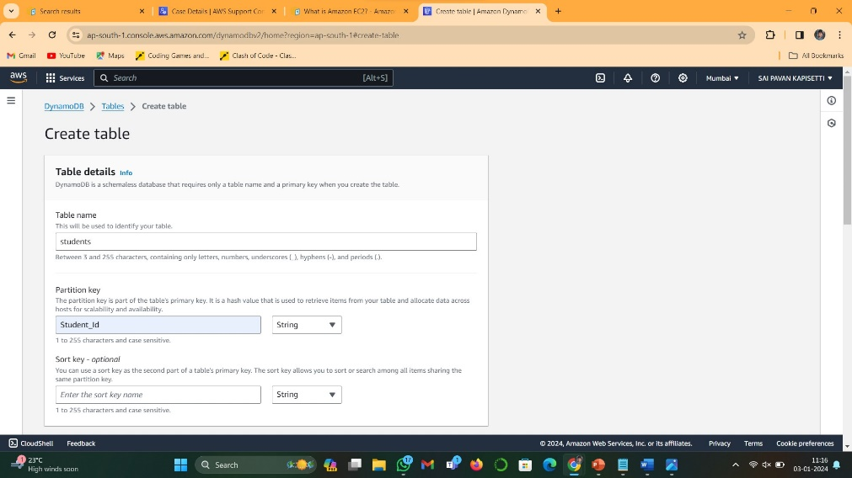

* Then click Create Table
* 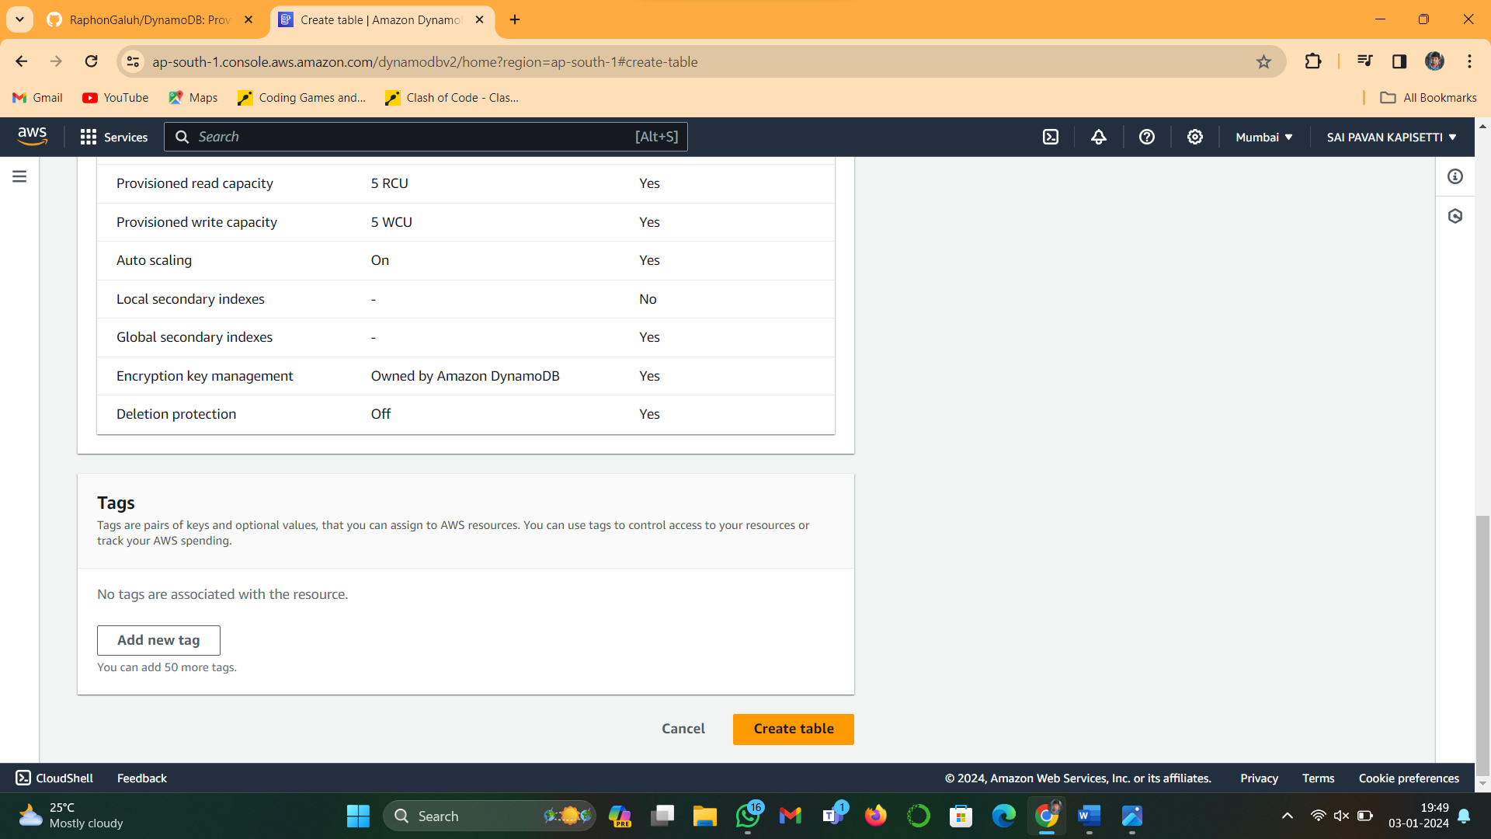
* The table will appear in the DynamoDB tables list. Wait a short while for the status table to change to active if it is initially still developing.
* 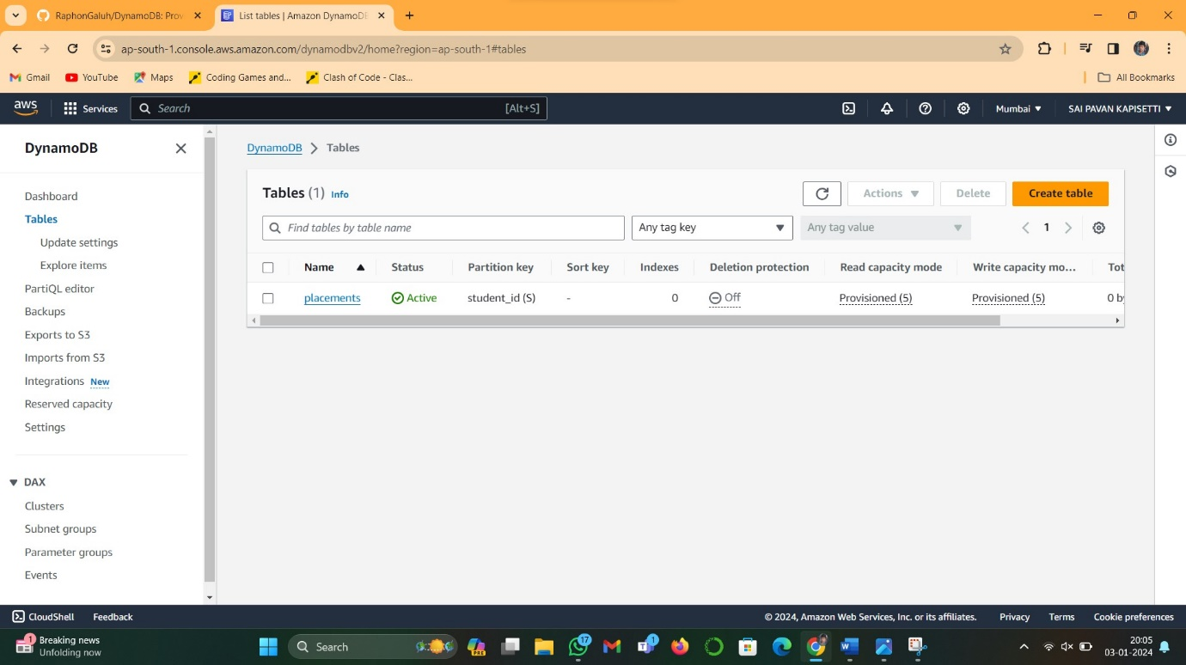
* Go to Explore items: your-table-name, select 'Create item'

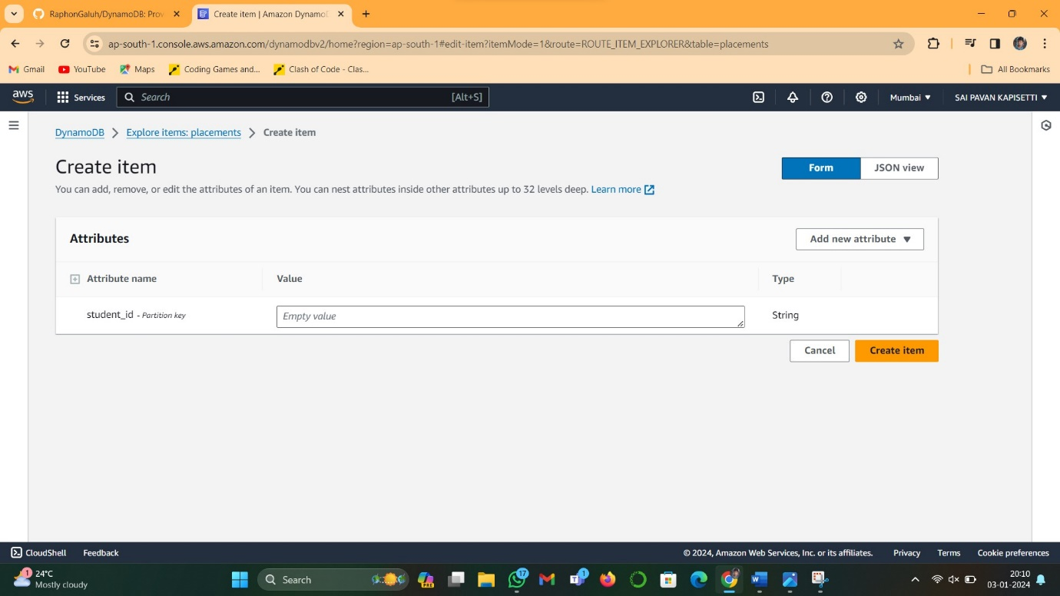

* Enter the value for the table attribute, and then select "Create item" to add data to the table.

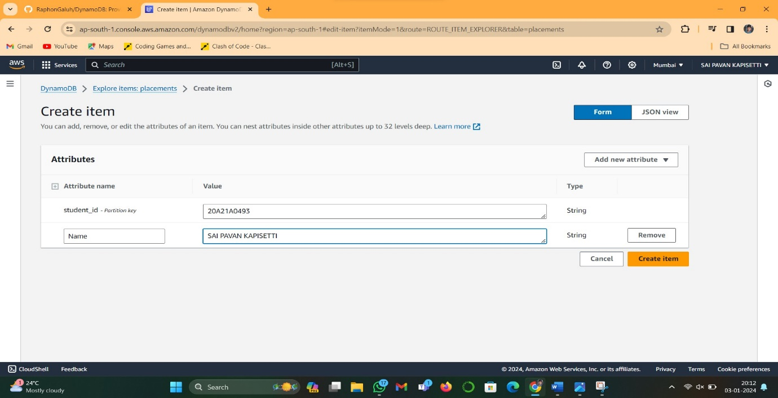

* It will be displayed like this.

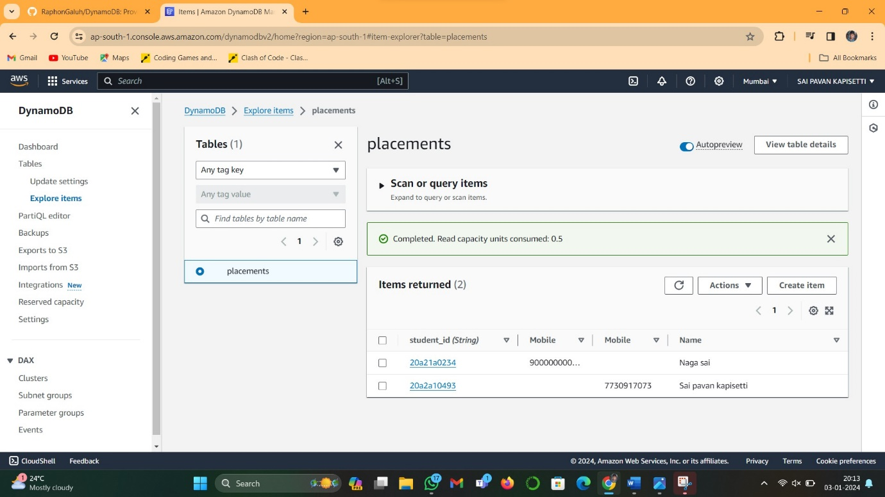

**STEP2: Importing Data from a CSV File.**

* Select DynamoDB from the menu, click Import from S3, and then select "Import from S3" to import datasets from an S3 bucket.
* 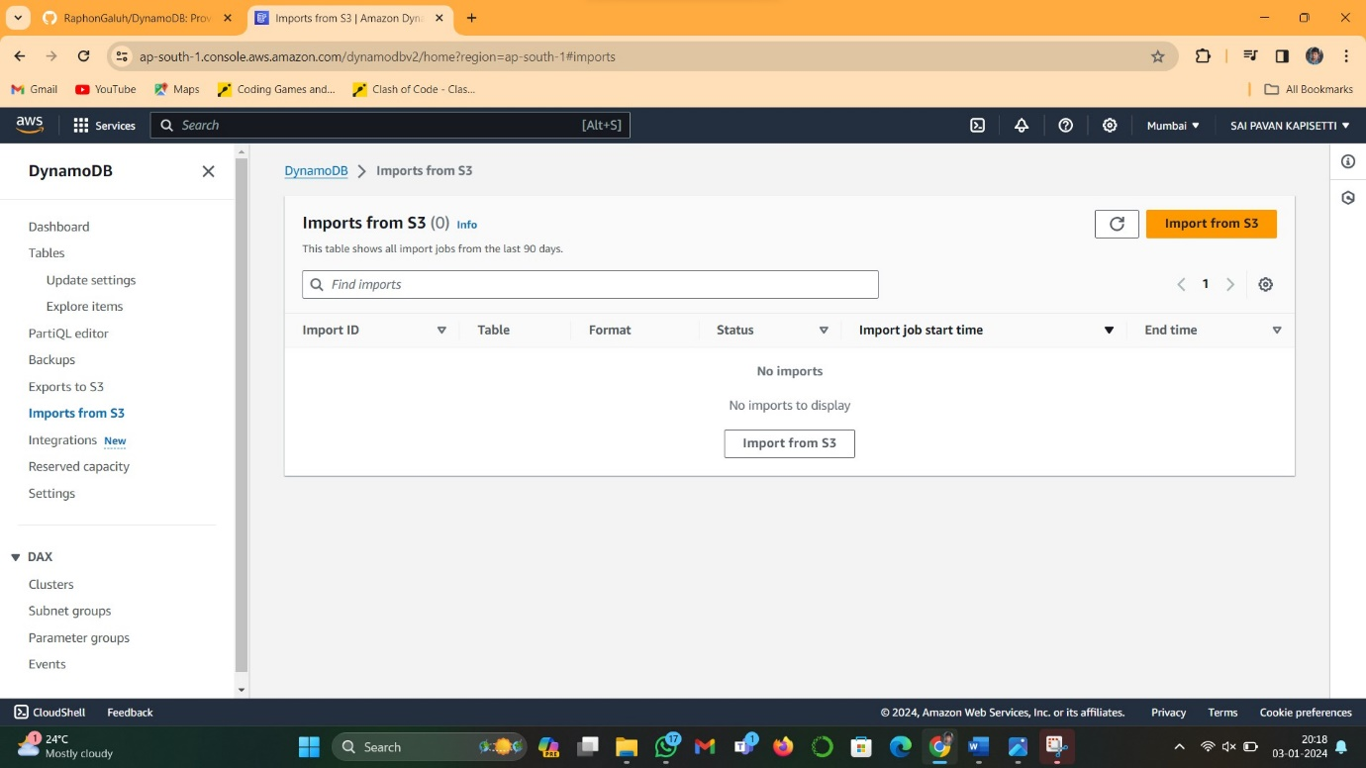
* Before anything else, I suggest uploading your CSV into s3 first. so you just need to browse it. Choose the format based on the first .
* 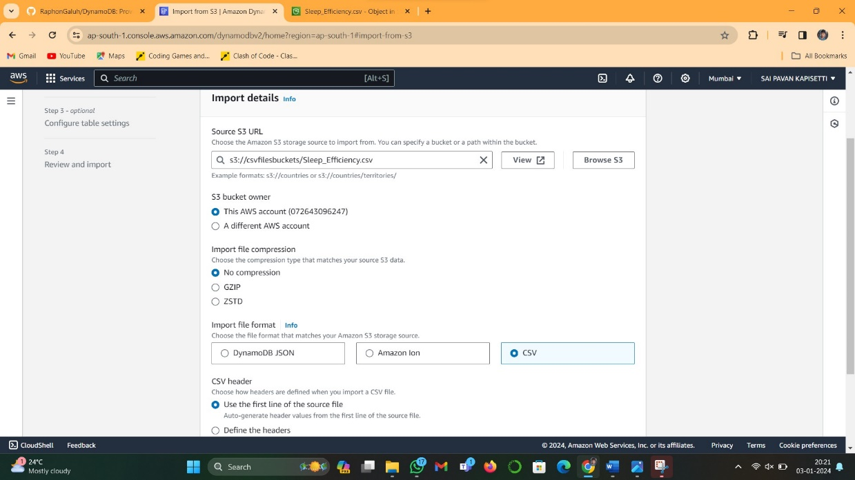

After that, fill in the table details, by inputting your table name and its primary key. *I change the file name to Saipavantable.

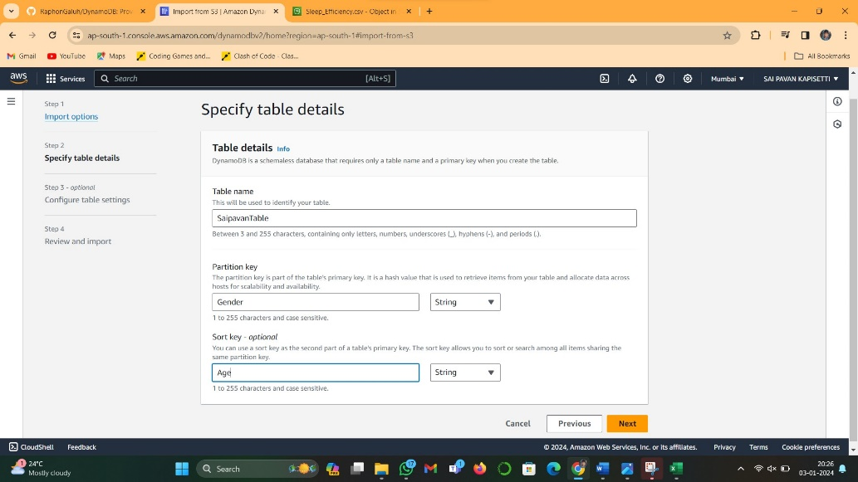

In the table setting, I choose the default setting.

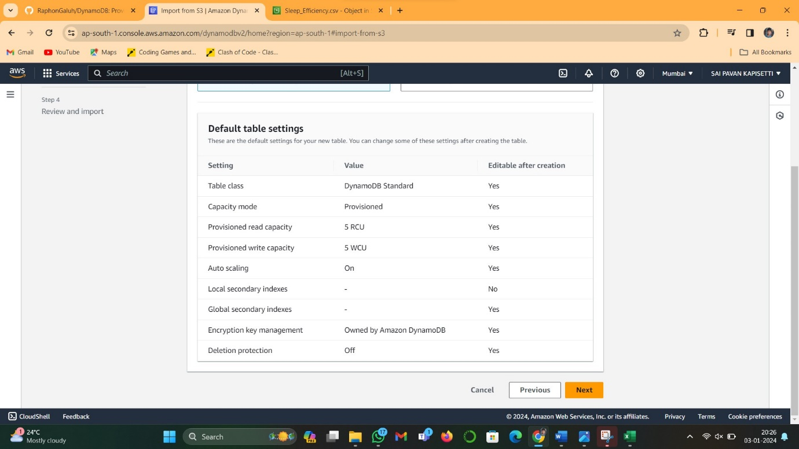

* Then on the review and import page, when you see that all the data is in accordance with what you wish for, click.
* 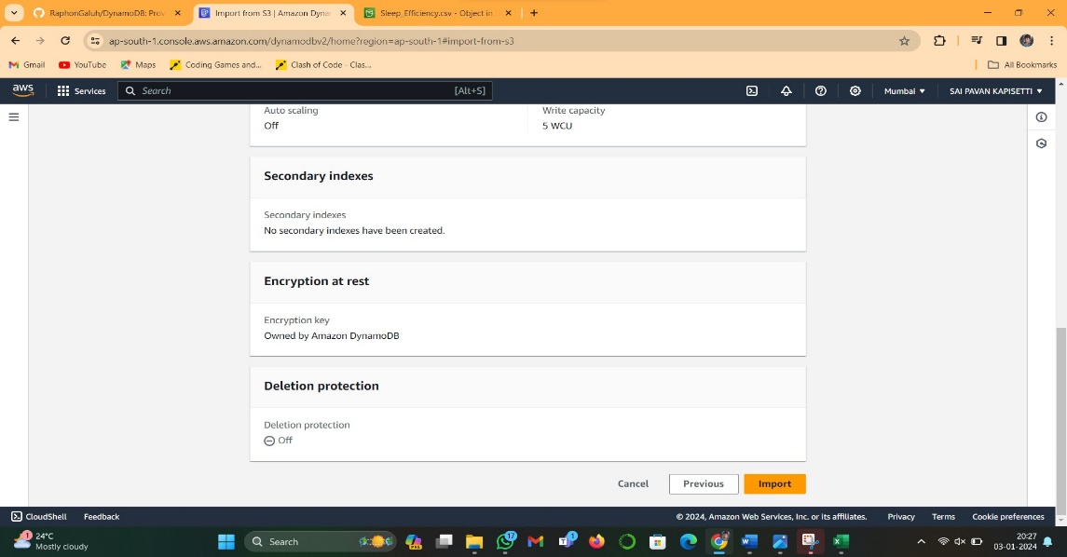
* It will take the file for a while to import, as can be seen in the status.
* 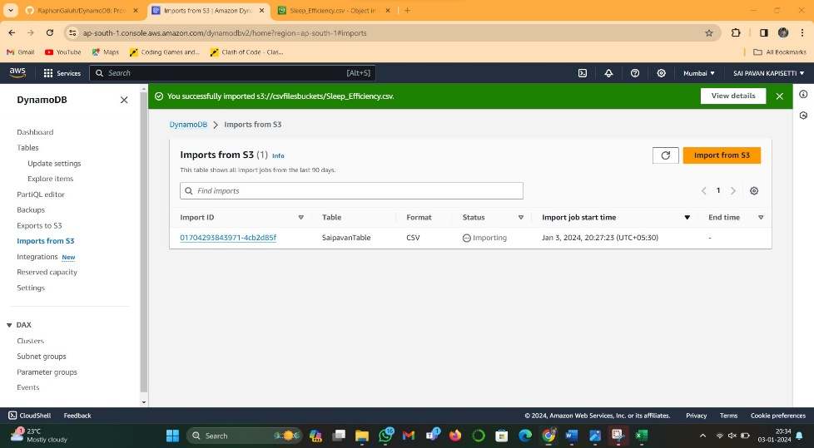
* We will wait until we have a green 'Completed' status beside the imported data.

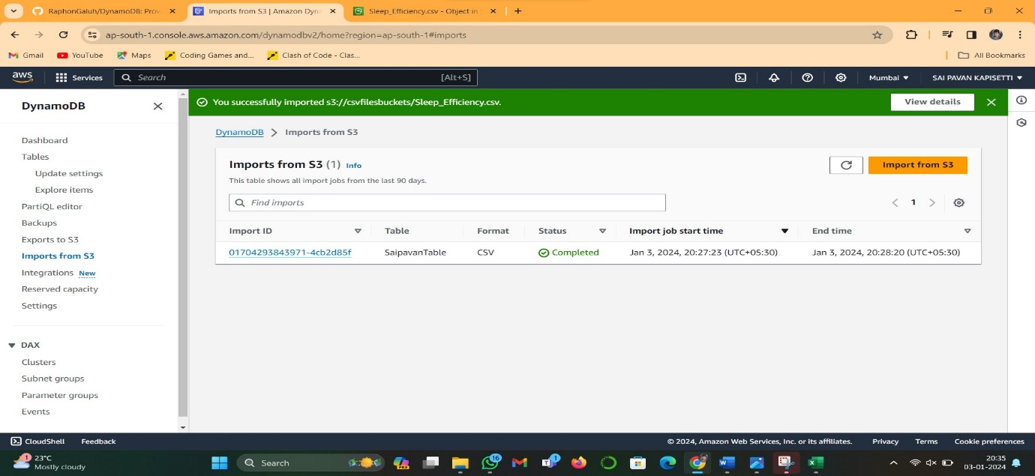

* When the file finished importing, we can see it by going back to the DynamoDB menu > Tables > Click our table > explore table item.

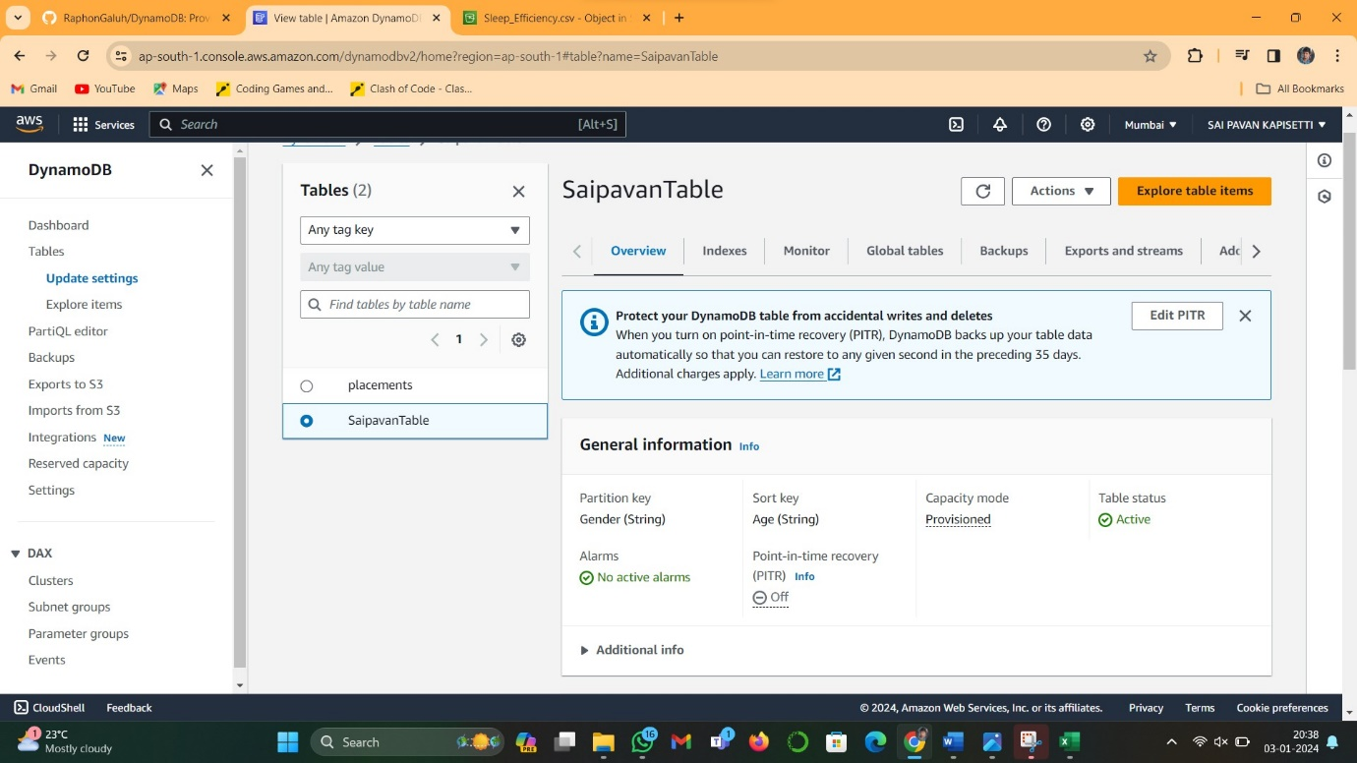

* This is the table that we just imported.

**Step 3: Performing Queries or Scans with Filters.**

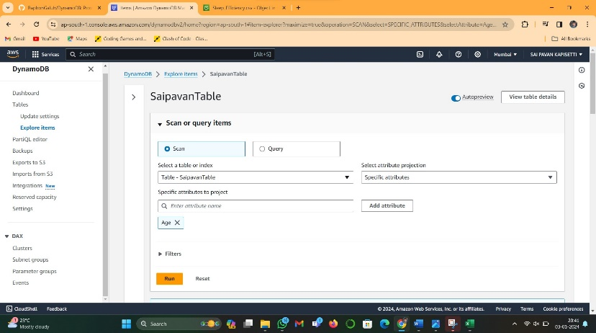

Scan Data.

Click on Explore Item and scan. You can explore this function yourself.

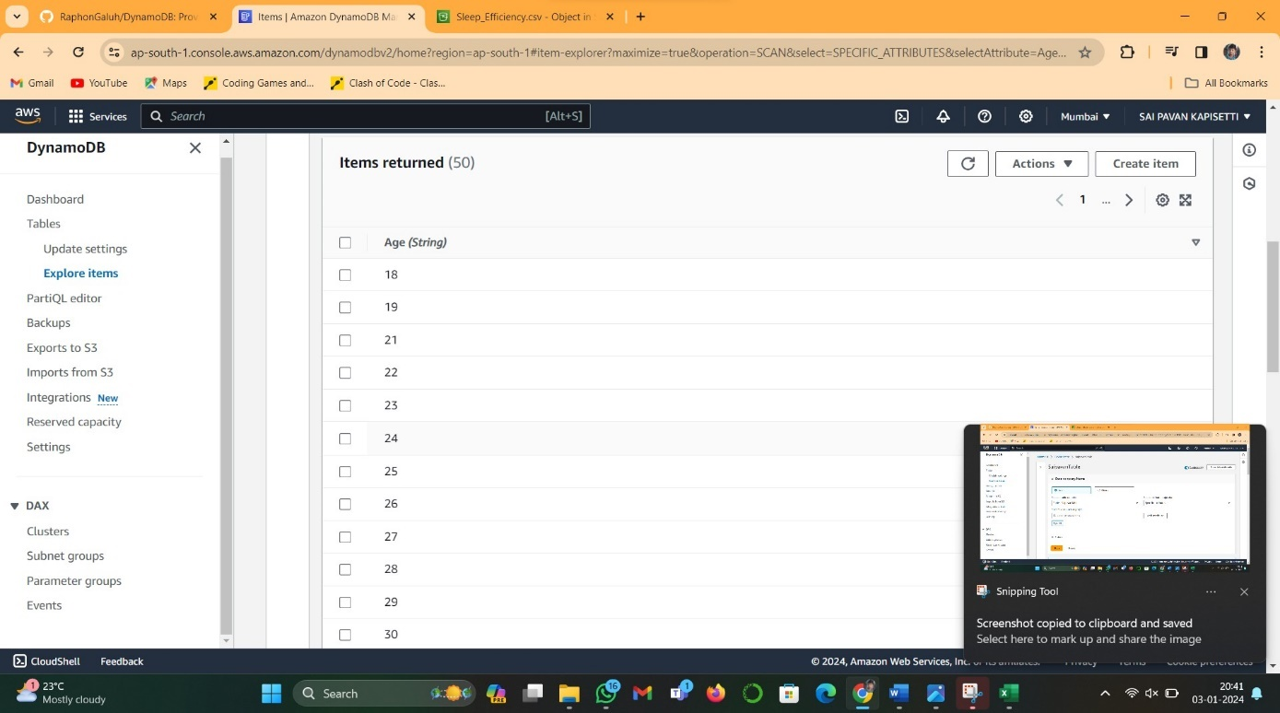

**Query:**

Click the query options on the same page as the last one. And explore the function ourselves**.**

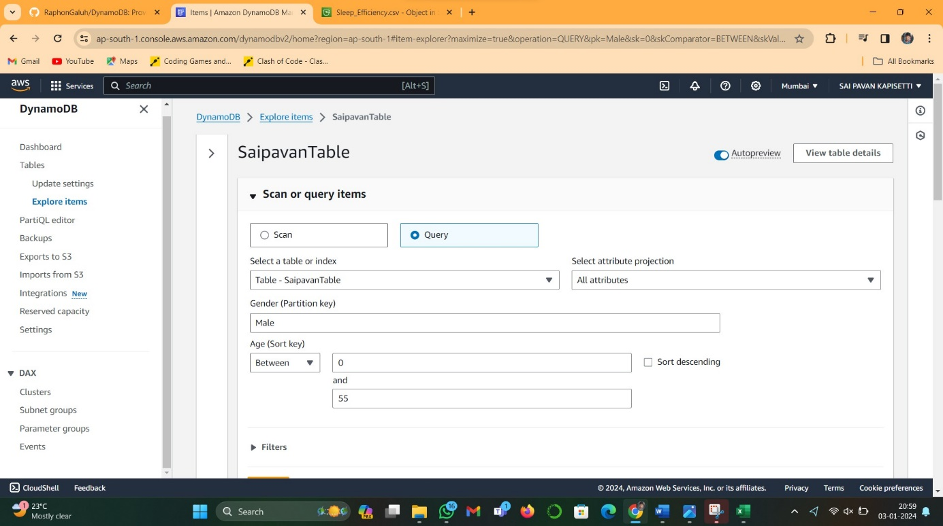

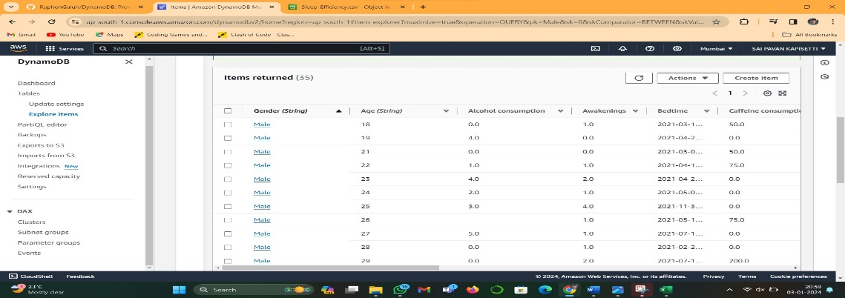

**Step 4: Exporting Results from DynamoDB**

* The last step is to export the data. First, we need to go to DynamoDB > Export to S3.
* 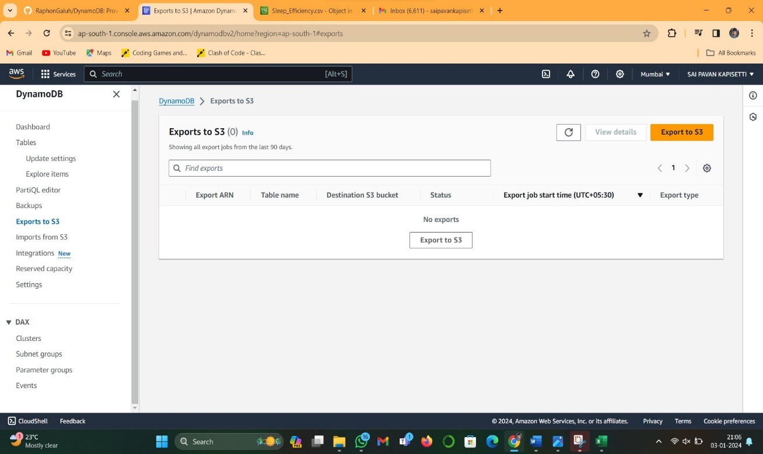
* Input your source table, and the destination bucket that you want to export it into > Export.

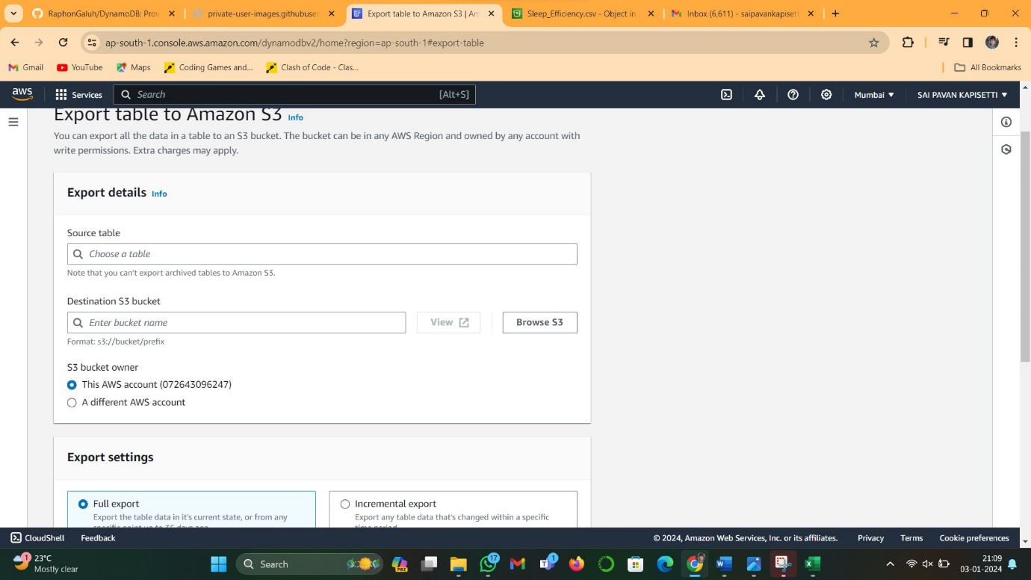

* We will wait until we have a green 'Completed' status beside the exported data.
* Then we will go to S3 > our bucket that we export our data in > and we will see our exported data as 'AWSDynamoDB/'.